Using pipe cleaners to express ideas about worship

An idea from Flame Creative Kids Blogspot that can be adapted to use with a pupil worship team for them to express their thoughts about what worship is in their school.
You need plenty of pipe cleaners.
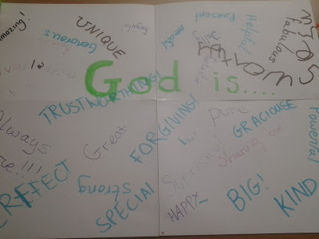
It's amazing to see how the children have really come to understand more and more what worship is, how we do it and why we do it!
Here is our latest attempt to show some hands-on creativity in worship...
First the children were encouraged to share words about who God was,
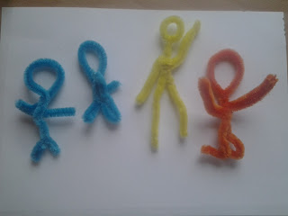

Next the children were asked to use a pipe cleaner to make a shape that represents worship of God in some way (something that reflects how amazing God is). They had so many ideas!
People praising God, praying or (in the case of the yellow person) holding a hand in the air "to say 'yes' because Jesus is so awesome!"

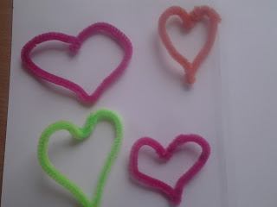
Various hearts to reflect God's love of us and our love for God.

A dove to symbolise God's purity. This child then said that half of the shape was yellow because God was 'golden'.
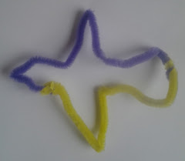

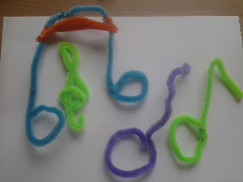
A variety of musical notes from children who found beauty in the music a reflection of God.

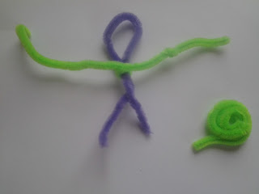

Two examples from a 5-year-old: a person dancing and a snail because even snails worship God (we had just been learning the verse from psalm 150 'Let everything that has breath praise the Lord'!)
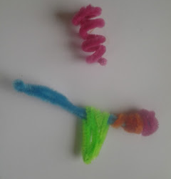
A flower and a spring to express the joy of spring and new life that God brings.

