


Week 1: The power of a story

Hidden treasure

Bring in a treasured story, or gather them from your class library.

As you look at our shared stories, which ones do you know? Which are new?

What ‘hidden treasure’ might they share with us?
How do stories help us to understand each other, or how to treat others?
Share some examples.


Week 2: Growing well

Seeds

As you look at our big seeds, think about how you might help these to grow in your heart.

How might we put these ideas into action as part of our school family?

Take away a small seed as a reminder of the part you will play in growing these qualities in our school. You might even want to plant it, take care of it and keep thinking as it grows!



Jesus told a parable about a tiny mustard seed and how it grew into a great tree, where all sorts of birds and animals found a home.

Hold a teeny-tiny mustard seed in your hand.

Who is a part of our school community? Who has ‘found a home’ in our school?

How can we make sure that everyone feels welcome, and at home here?
Maybe pause and pray…..

© ‘The mustard seed’, with thanks to Anne Brink

Week 3: A place of welcome


Jesus said: “The kingdom of God is like yeast that someone takes and works into flour.”
You only need a tiny amount of yeast to make the bread rise: it makes a BIG difference!

Take a card from the mixing bowl and read what it says.

Think about how you might bless someone else with this one small deed today….

…then put the card back in the bowl, and look out for the chance to do what it said!

Week 4: Agent of change
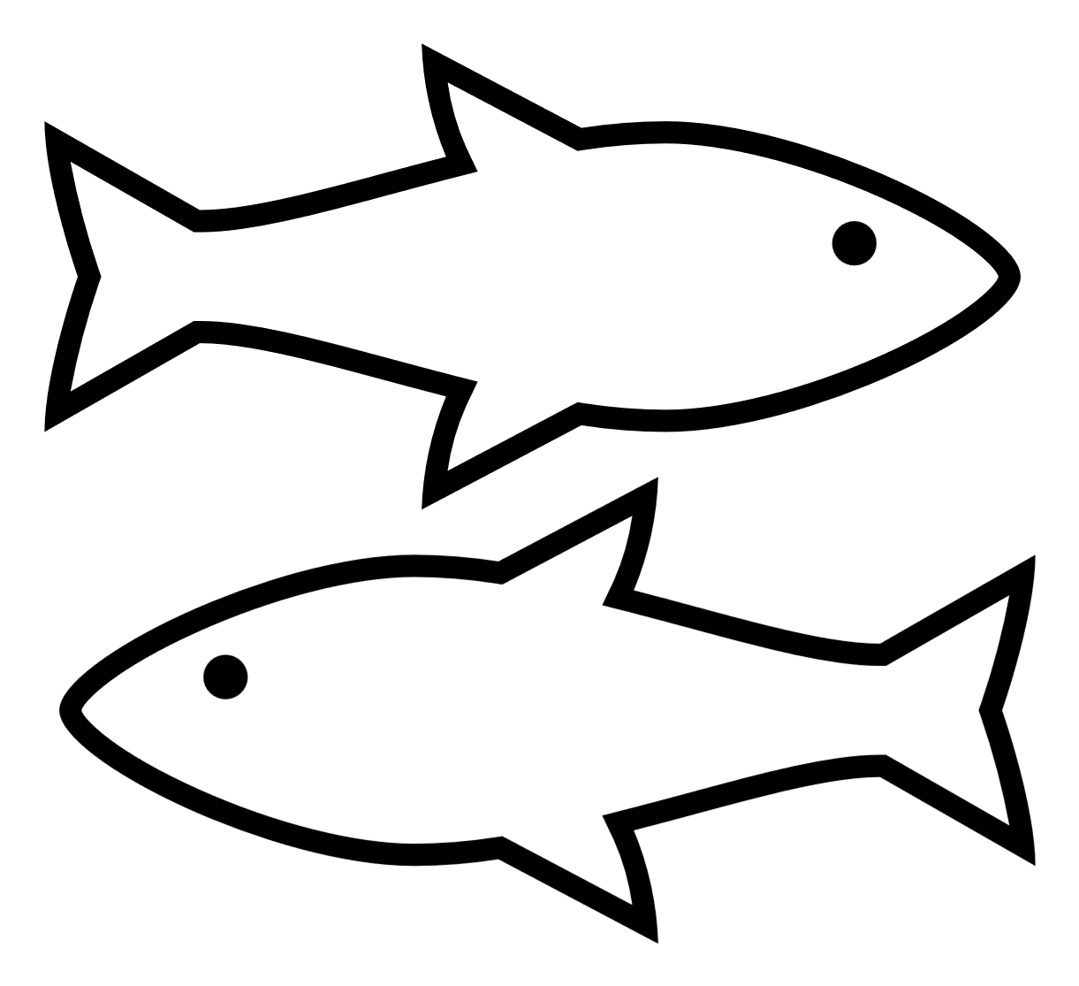

Jesus told a parable about fishermen sorting good fish from bad fish.

‘Catch’ a fish using the magnetic rod. Read what the cards says.

Is this a ‘good’ fish or a ‘bad’ fish? Talk about the challenges that you might face making the right choice.

Think about what might help you to make good choices going forwards.

Week 5: Good fish, bad fish


When Jesus said goodbye, he sent his followers a very special gift…a gift that would be their helper…a little piece of heaven in their hearts. This helped the very first Christians to share everything they had with each other….
Think of something that you might share with others.

Talk about how it feels to share. Is it easy or difficult? Are some things easier to share than other things?

Write or draw on a small gift label then put it inside the box …..you might like to ask God to help you to share.

Week 6: Going up….and coming down
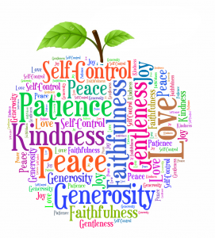

‘The fruit of the Spirit is love, joy, peace, patience, kindness, goodness, gentleness, faithfulness (loyalty) and self-control.’

Take an apple out of the bowl and hold it in your hand as you think about the word….

How might we be more loving, or peaceful, or patient, or gentle here in school? How do we ‘practise’ these things?...

Take a few moments to think or pray if you’d like to….

Week 7. Growing good fruit (Sower 2)


Week 8: A united body

St. Paul wrote: ‘…God put the parts in the body as he wanted them. He made a place for each one of them.’

Pick up a piece of jigsaw puzzle and think about how it has a special place. You have a special place as part of our school family.

Think about times when you feel you really belong at our school.

As you build the puzzle together, talk about ways we can value everyone in our school community.





The words we speak have great power.

Take a gemstone out of the bowl and hold it in your hand.

Think about words that you might say to help or encourage others.

Now place the gemstone back in the bowl, and go and speak those words to others!
Week 9: Toads…..and jewels!




‘When others are happy, be happy with them, and when they are sad, be sad with them.’
(Romans 15:12)

Is there anyone you know who is sad today?

Take a ‘tear’ and hold it in your hand. Then pop it into the bottle as a way of bringing their sadness to God.

You might want to go and find that person and speak some words of comfort to them.

Week 10: Why the moon is sad


Kiwi’s brave actions saved the trees. He served the others by giving up his home to live on the forest floor.

Talk about your thoughts about Kiwi’s actions. What might have been hard for him in making the decision he did?

How might your actions serve others today?

Take a small heart and pop it into your pocket to remind you to take action.

Week 11: The brave kiwi


Tiddalik the giant bull-frog swallowed all the water in the billabong and wouldn’t share with anyone else.

Think about the story of Tiddalik and how his actions meant that there was nothing for anyone else.

Talk about how we can be more careful and responsible in the way that we use water.

Each time you do something to save water, place a glass bead into the bowl.

Week 12: The frog who wouldn’t share


Planet Earth is our beautiful shared home

Think about the things that you love about our beautiful Planet Earth.

Talk about how we can be more careful and responsible in the way that we live. What promises should we make?

Write your idea on a plaster and stick it onto the world map to show your promise. You might also want to pray for God’s help.

Week 13: The fragile gift

