



‘Shine like stars!’

What are you looking forward to in this new year?

What might you wish for your family, your school, or our world in 2026?

Take a star shape and write or draw your thoughts on it. You might want to hang these up in your classroom.

Week 1: Happy New Year! – 2026


‘Shine like stars!’

Which of the actions in the story ‘shine like stars’?

How might our actions ‘shine like stars’ this week?

Take a star shape and write or draw your ideas on it. You might want to hang these up in your classroom with last week’s stars.

Week 2: Food, glorious food!



Do what’s right

Pick a starry challenge card and read the scenario on the back.

What is the right thing to do?

What might help you to do the right thing?
What might make this a hard thing to do?
How might we help each other?

Week 3: In the fiery furnace


Week 4: Daniel and the dreams

Be wise: act humbly

Who would you rather be like – Daniel or King Nebuchadnezzar?

What does this mean for how we might treat others this week?
How might we serve each other and be wise in our actions towards others??

Pick up a star and hold it in your hand. You might want to turn your thoughts into a prayer, like Daniel did.


Positive messages

What message might help others to ‘live out’ your school’s vision or values this week?

Write or draw this message onto the class message wall this week.*

At the end of the week, talk together about the difference that the messages might have made in your school community.

Week 5: The writing on the wall


Be courageous!

Think about the stories of Daniel that we have explored so far this term. What have you learned from them?

Talk about what might have helped us to ‘shine like stars’.

Write or draw your thoughts onto a star and add it to your class display.

Week 6: In the lions’ den


Love is…..

Think about what ‘love is…..’ for you, or something you could do to show love for someone else..

Take a shape and write or draw your idea into the heart, then add it to your class display.

At the end of the week, look at all the different ideas you have collected. Which ideas are most common?
Week 7: Heroes of hope – Love is…. (version 1)



Love is…..

Think about what ‘love is…..’ for you, or something you could do to show love for someone else..

Make a chain of paper hearts, and draw or write your ideas onto the hearts.

At the end of the week, look at all the different ideas you have collected. Which ideas are most common?

Week 7: Heroes of hope – Love is…. (version 2)
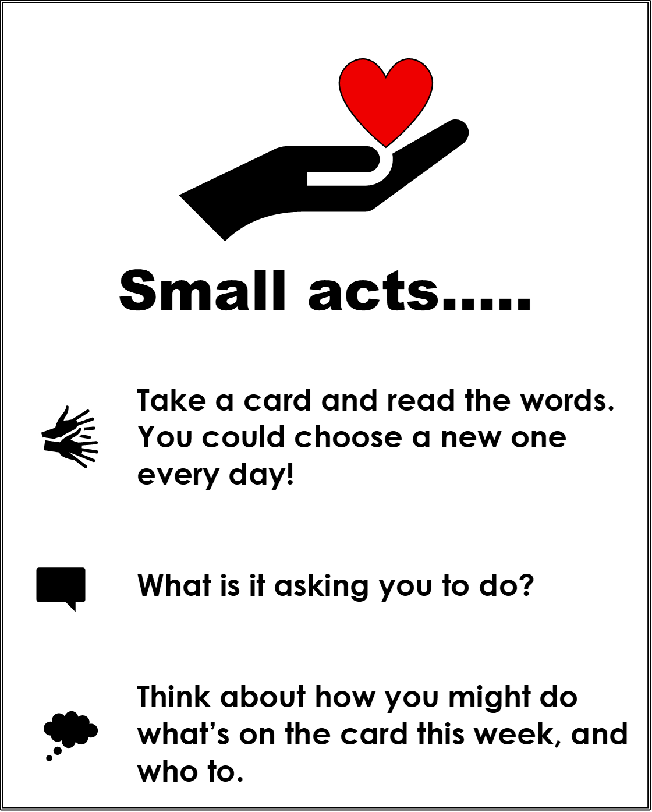

Week 8: Heroes of hope – Everything could be a prayer

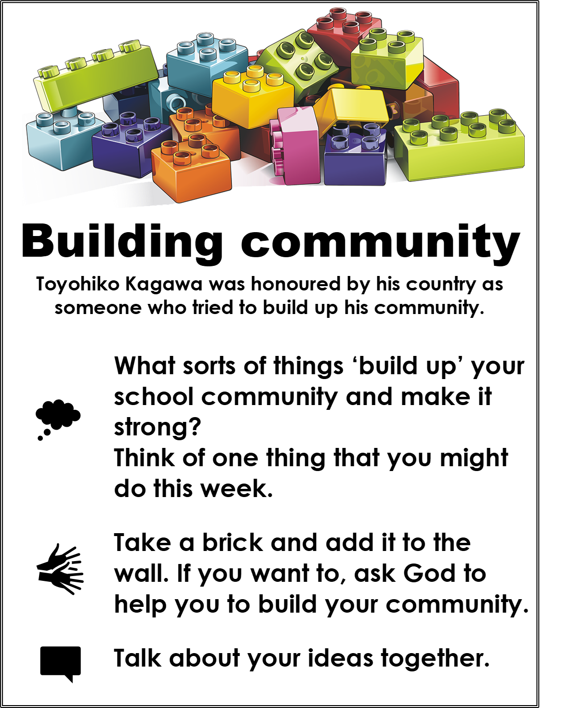

Week 10: Heroes of hope – Who is my neighbour


Week 10: Heroes of hope – The great giveaway

Chain of love
St. Alphonsa said ‘Love is the greatest gift we can give.’
How did St. Alphonsa give love away during her life? How might you ‘give love away’ this week?

Take a heart shape and write your idea inside it. Make a class ‘chain of love’ around your classroom. Try to find an opportunity to act on your idea this this week.

At the end of the week, look at all the ideas you have gathered and find out what a difference they have made.
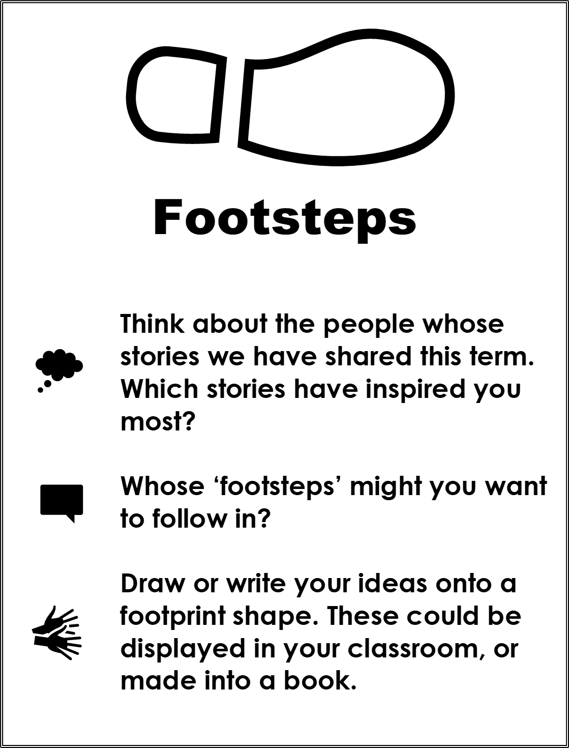

Week 11: Heroes of hope – In their footsteps

